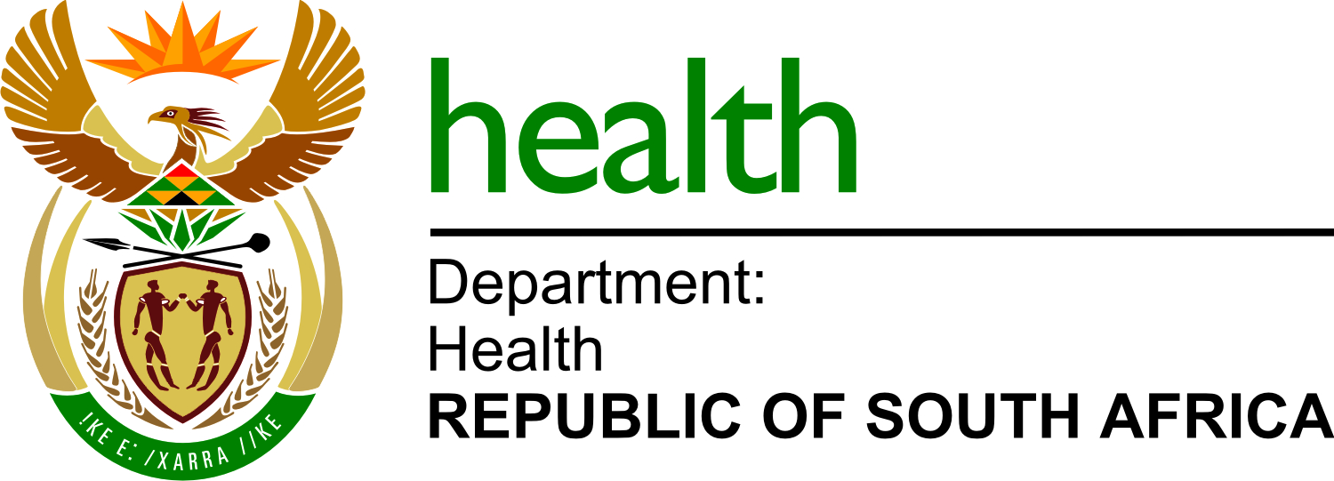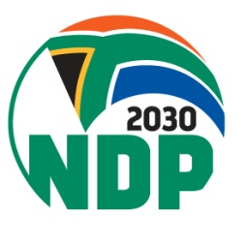
Private Bag X828, PRETORIA, 0001 Dr AB Xuma Building1112 Voortrekker Road, Pretoria Townlands 351-JR, PRETORIA, 0187
Tel (012) 395 8000, Fax (012) 395 8918

Dear Dispensing Licence Holder
NDoH Dispensing Licence Annual Fees – due 28 February 2025

Kindly ensure that your annual fee payments are up to date (R200 per annum).
Payments can be made via Direct Deposit or Electronic Funds Transfer (EFT)
Fees are payable by 28 February of each year.

Payments to the National Department of Health are payable to the following account:
Banking details:
Bank : ABSA
Account Holder : National Department of Health
Branch : Vermeulen Street
Branch code : 632005
Account No. : 405 364 3510
Account type : Cheque account
Beneficiary Ref. : Statutory Council Registration Number ONLY
Note: Where the Statutory Council Number is less than 8 (eight) numbers – please add zero’s at the end to make up 8 (eight) numbers.
Please email proof of payments to dispensinglicencefees@health.gov.za.
Ensure that the subject line reflects as follows: Initials, Surname, Council Registration Number – Annual Fees [e.g. Dr AB Cee, MP123456 – Annual Fee Payment]

Kind regards
Licensing Team
National Department of Health

Visit our page on https://www.health.gov.za/licensing-home/

